CMS ACTIVITY -3

Mind

What motivates me?

Well, there are various things with motivates me; first spending quality time with my family. Second is to keep my goals simple and small. After completing my goal I like to reward myself. Third is reciting sacred prayers. Forth is the hilarious TV shows such as Kapil Sharma and many more.

What stops me?

To be honest, nothing can stop me if I put my mind on the specific thing.

Body

What motivates me?

Certainly, it is I and the people around me who encourage me. To maintain my shape and diet.

What stops me?

The work load, projects, and even I when I see it is not that crucial at that moment.

Purpose

What motivates me?

To give my family a comfortable, a peaceful and tension free life.

What stops me?

Nobody, it is only the hard work we put to achieve that life.

Spirit

What motivates me?

The motivational quotes, prayers and blessing of my parents or grand parents

What stops me?

Sometimes, I loss it because of the unpredictable situations.

Emotion

What motivates me?

Support of my family and friends

What stops me?

Judgmental looks, not trust me enough, and backbite me.

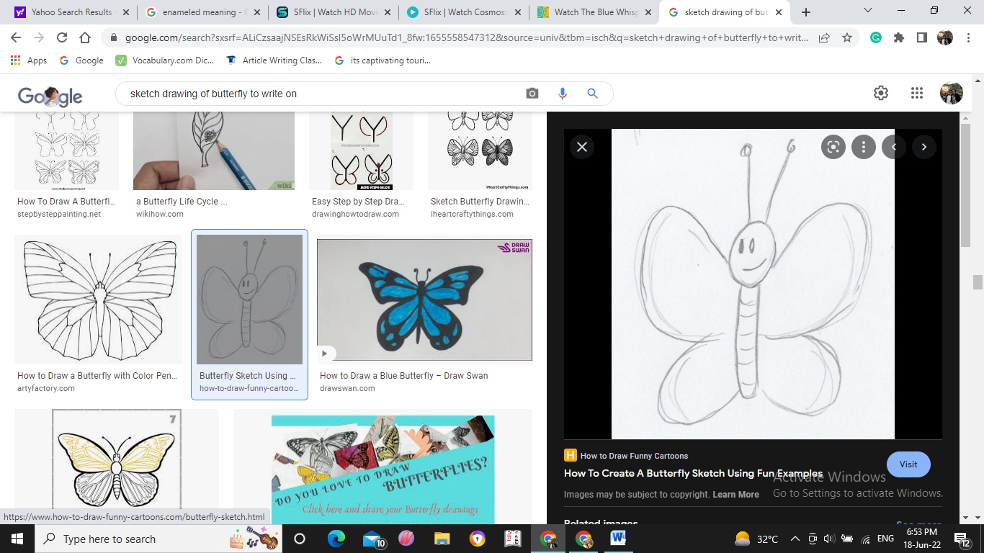Self-commitments

1. Always respect my elders and value them.
2. Always tried to be better version of myself than me which is yesterday.
3. Always believe in myself as everything is possible.
4. Never regard myself lower than someone else.
5. Respect everyone and admire them because of their talent and hardwork.